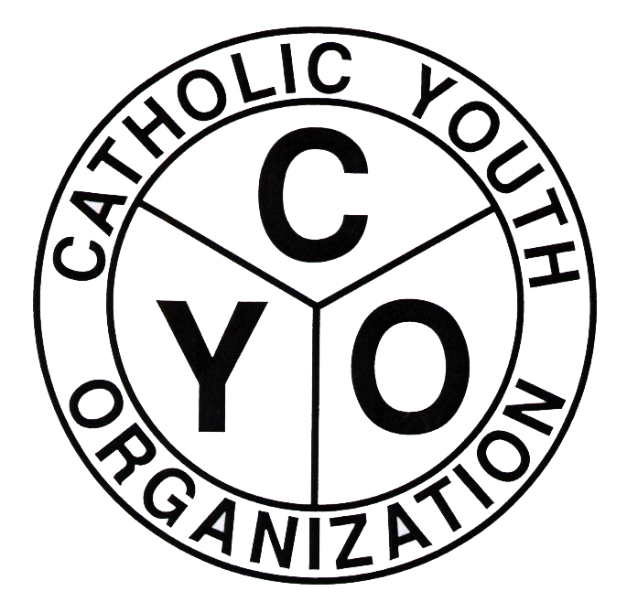
Catholic Youth Organization
7200 Douglaston Parkway
Douglaston, NY 11362
Phone: 718-281-9550
www.cyodob.org
DIOCESAN LEAGUE
Basketball Court Availability Form

Parish: ____________________________________________________________

Address of Home Court: ______________________________________________
(Please provide complete address for use of GPS)

SEPTEMBER THROUGH NOVEMBER YEAR/SEASON: ___________________

The court is available for CYO games on:
Fridays: 1st game starting__________ last game_______________
Not available on these Fridays:_________________________________
Saturdays: 1st game starting__________ last game _______________
Not available on these Saturdays:________________________________
Sundays: 1st game starting__________ last game _______________
Not available on these Sundays:_________________________________

Available weeknight dates
Mondays: 1st game starting_________ last game ____________
Not available on these Mondays: _____________________________
Tuesdays: 1st game starting_________ last game ____________
Not available on these Tuesdays: _____________________________
Wednesdays: 1st game starting_________ last game ____________
Not available on these Wednesdays: ___________________________
Thursdays: 1st game starting_________ last game ____________
Not available on these Thursdays: _____________________________

This court may be used as a neutral site for regular season games: YES NO

This court may be used for the diocesan playoffs: YES NO

Comments:________________________________________________________________________________________________________________________________________________________________________________________________

